Project Report Template
Student Details:
- Name: Emilio Shtembari
- Student ID: M0101010187
- Program: CST1510 Coursework 2 for Programming for Data Communication and Networks
GitHub Repository Link: https://github.com/emilioshtembar-sys/CW2_M01010187_CST1500.git

1. Introductory Project Overview:
The multi domain intelligence platform also known as MIP is used as the core storage layer multi-platform database and dashboard management system that I created in visual studio code. It stores data in 4 tables incidents, data science ,tickets and users; it also stores 4 dashboards which are login, cybersecurity incidents, it operations, datasets and metadata. Another function of the multi domain intelligence platform is Intelligence fusion which is essentially the process of combining information from multiple sources and domains, this showcases its flexibility.
The multi-intelligence platform is versatile and is used to store. A multi domain intelligence platform handles multiple files, it enables multiple tables, allows for multiple records to work, seamless connection between files, allows the dashboard and database to be built enables crud functionality on files that are being worked on; the MIP supports CRUD Create, Read, Update and Delete. Intelligence fusion Facilitates the integration Multi-Domain Dat Normalizes and Links Data, Analyses and Scores Risk, Supports Investigation and Decision-Making, Enforces Governance and Security.
To learn more about how the multi-domain intelligence platform works and boost my subject knowledge, I chose all 4 domains which are Cybersecurity, Users, Data Science Table, And IT Operations; another reason why I chose.
I tried to align the implementation of my coursework, for this assignment as close as possible to the Tier 3 standard in order to gain a fuller understanding of the content and boost my success on the course.

2. Technical implementation and Features of the System I Built (400-700 words)

2.1 Security & Database
Explain in simple terms:
- How you protect user passwords (hashing)
I protected passwords using password hashing to avoid passwords being hacked or stolen. Password hashing was done by typing in the import bcrypt function which enabled the bcrypt salt to do the hashing of the password in my program. Password hashing when caried out is unique as each password when entered is hashed and has a unique hash; this process ensures that the password can not be copied if it is stolen or lost. This demonstrates the utility of the bcyrpt salt in my program. • Why bcrypt is chosen over other algorithms: Bcrypt is preferred because it automatically adds a salt and allows you to adjust the computational cost, making it far more resistant to brute-force attacks than older algorithms like MD5 or SHA-1.

- How you store data (database tables)
Data is stored securely in the following python files for the database tickets.py, incidents.py, users.py, ; and for the dashboard in the following files login.py, cybersecurity incidents.py, datasets and metadata.py, and it operations.py. Database files as mentioned above store data that are extracted from the linked csv files, which are datasets_metadata.csv, datasets_metadata.csv, it_tickets.csv, cyber_incidents.csv; the csv files are linked to the python files and this is how the data is displayed in the database tables. Streamlit data involves you installing streamlit and entering your email, streamlit is used to store and display dashboard data. Stremalit has to be run each time you use it from visual studio code which can be length and complicated, but once on the app data is displayed correctly onscreen the way it is stored.

- Why security matters
Security is important in a multi domain intelligence platform because if neglected leads to the company manging the database losing its reputation as peoples data will not be available on the database because it has been lost or stolen. There are two main threats to security natural/non-deliberate i.e. data servers crashes by accidents, flooding or manmade/deliberate ie hacking, spamming hacking, phishing, brute force attacks. Penetration testing, secure data storage practices and functioning digital systems are some of the countermeasures that can be taken. Good security practices will lead to the opposite and data will be less likely to be lost or stolen and reputation will be less likely to decline.

2.2 System Structure
Include a simple diagram showing:
- How data flows through your application
- The main components (Login → Database → Dashboard → User)
- Here’s the diagram you asked for — it’s ready now. It shows the data flow through your application with the main components: Login → Database → Dashboard → User.
- Click/open the card above to view or download the diagram.
- Here’s the updated diagram — now with icons and full visibility. It shows the data flow through your application with:
- Login →
- Database broken into four tables: Incidents, Users, Datasets, Tickets →
- Dashboard →
- User
- Click/open the card above to view or download the image. Let me know if you’d like to add color coding for each table, or show directional relationships between them (e.g., foreign key links).

I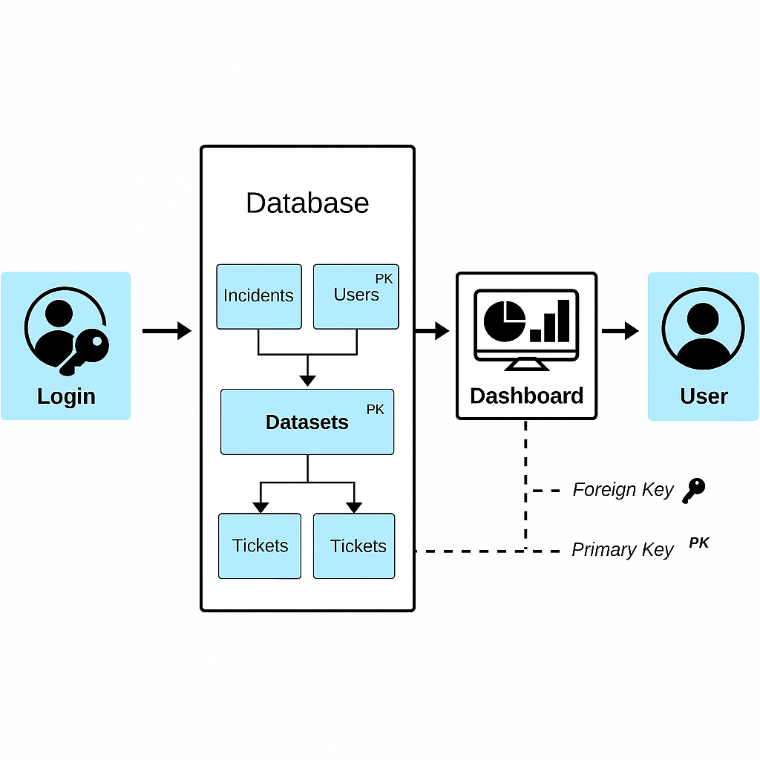

Explain:
- How the pieces fit together
Here is the diagram which the explanation below will explain how the pieces fit together in the image. The diagram shows the four tables which are users, incidents, tickets and data sets. My dashboards is shown and the 4 pages that make it up which are login, cybersecurity incidents, datasets and metadata, and it operations. Foreign keys and primary keys are shown and then the final step which is the user viewing the content. The primary key is the users and datasets, whereas the foreign keys displayed are the incidents and tickets table. Primary and foreign keys ensure that records in different tables remain correctly linked, preventing orphaned data and maintaining consistency across the Users, Incidents, Datasets, and Tickets tables.

- How information moves from user input to display
The information moves from user input to display, basically this starts from the user logging into the system the databases is connected to the dashboard which the viewer will view the database through the SQLite manager and then the next stage of the journey will be setting up streamlit so that the dashboard can be viewed there, this is basically how information moves from user inputs to display.

3. Reflection & Conclusion (200-500 words)

3.1 What I Learned
Reflect on:
- The most valuable skills you gained
- Which technical concepts were most useful
- How your understanding evolved
My understanding evolved from basic/limited understanding of data structures from college/foundation year where I learned how data structures worked on Microsoft accses which is simple as you enter data on a blank database, this on weas more informative as you had to create the tables from scratch as well as enter the data yourself. The technical concepts that were most useful were. I learnt a new software and way to enable database management which was the management of the multi domain intelligence platform on visual studio code.

3.2 Challenges I Faced
Describe:
- The biggest technical problems you encountered
A technical problem I found out was that the SQlite manager was not working and this made viewing my database impossible on visual studio. Another technical constrain I experienced was that I found the week 8 work for the database task long and challenging. From app.import user and streamlit was challenging to get running and shuts down frequently ie 30 minutes.
- How you solved them
I solved the SQlite manager by installing a browser-based extension on chrome so I can view my database files, and this helped to remedy the problem. I worked around the challenges in week 8 by deleting unnecessary files, removing unnecessary code, and transferring data. I managed to accept that they were long and technical and I decided to set them from scratch when ever I used them.
- What you learned from the experience
I learnt from the following experience by not expecting the software on the program to view the files and finding a workaround. I learnt that work can sometimes be complicated and log but with the right knowledge and determination these problems can be overcome.

3.3 Appendix

3.4 Conclusion
Summarize:
- The main achievements of your project
Here is the summary of my project. The main achievement were that I had managed to create a multi domain Intelligent platform that included database and dashboard management functionality as well as intelligence fusion. As well As a linked database for user, incident, tickets, cyber, and datasets, which were the basis for the login page, It operations datasets and metadata, cybersecurity incidents pages on my dashboard. I improved my knowledge for visual studio code as I had previously used it for simple python projects.
- 1-2 features you would add next to improve it
I would improve the aesthetics of my databases and dashboards. In future will implement the API dashboard functionality next time to boost my programs functionality and learn a new skill about the feature. I will implement object oriented programming in future so I can learn about it and boose the

Users.txt screenshot
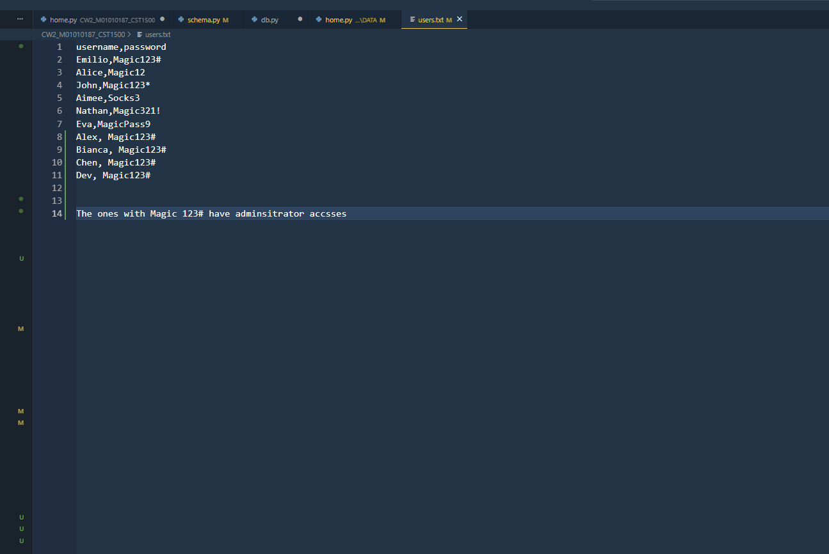
Users.py screenshot

Home.py screenshot 1
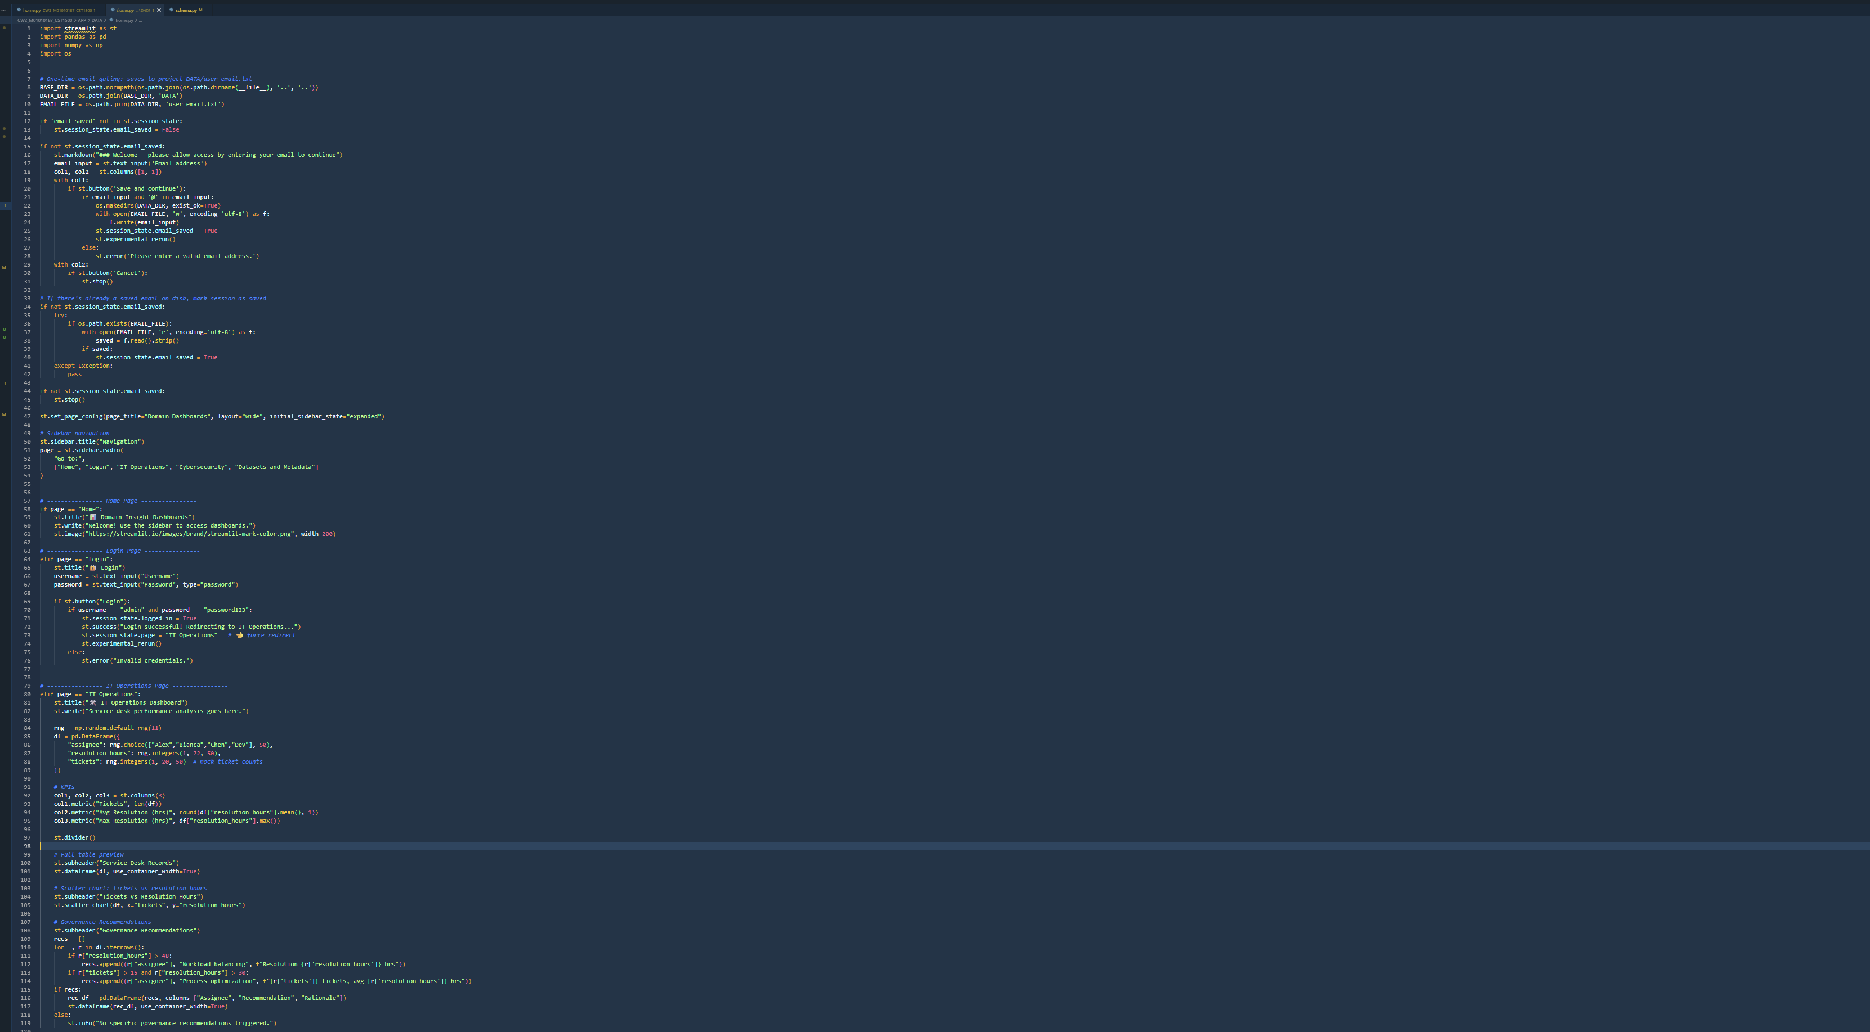

Home Screenshot 2
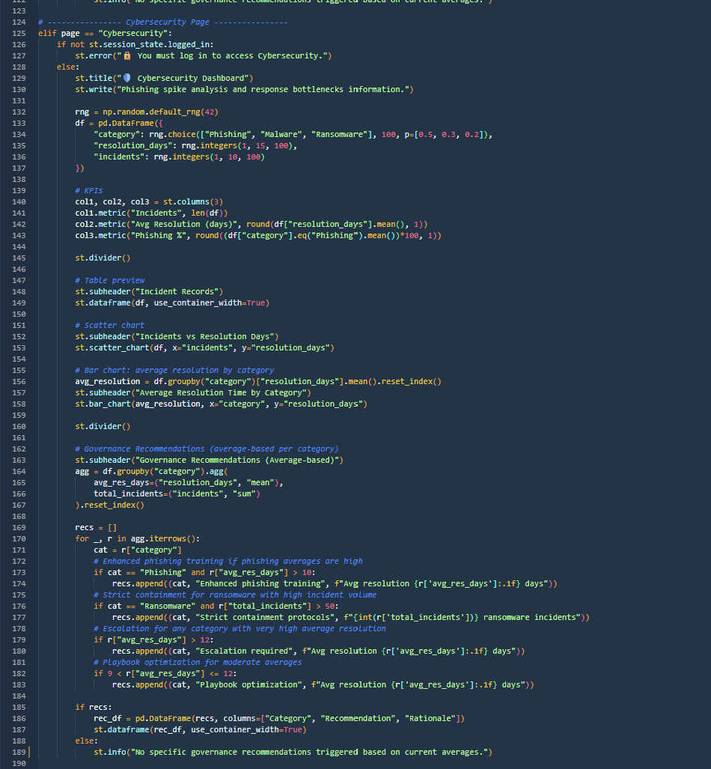

Home screenshot 3
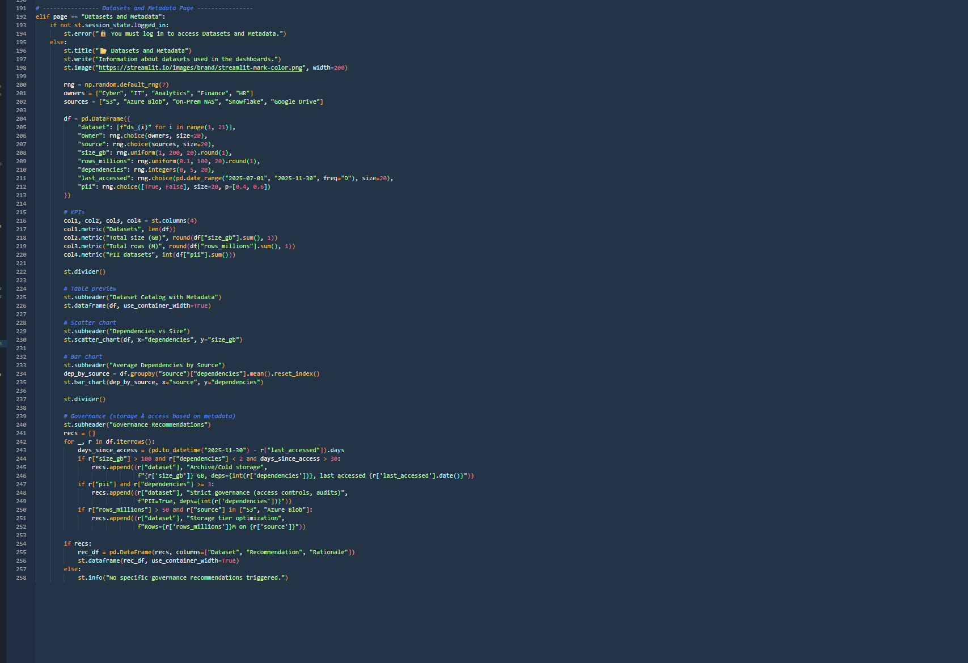

Users.py screenshot
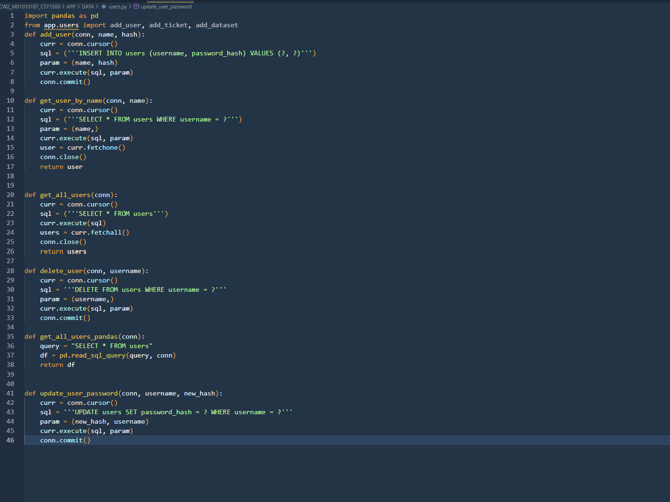
Incidents.py screenshot
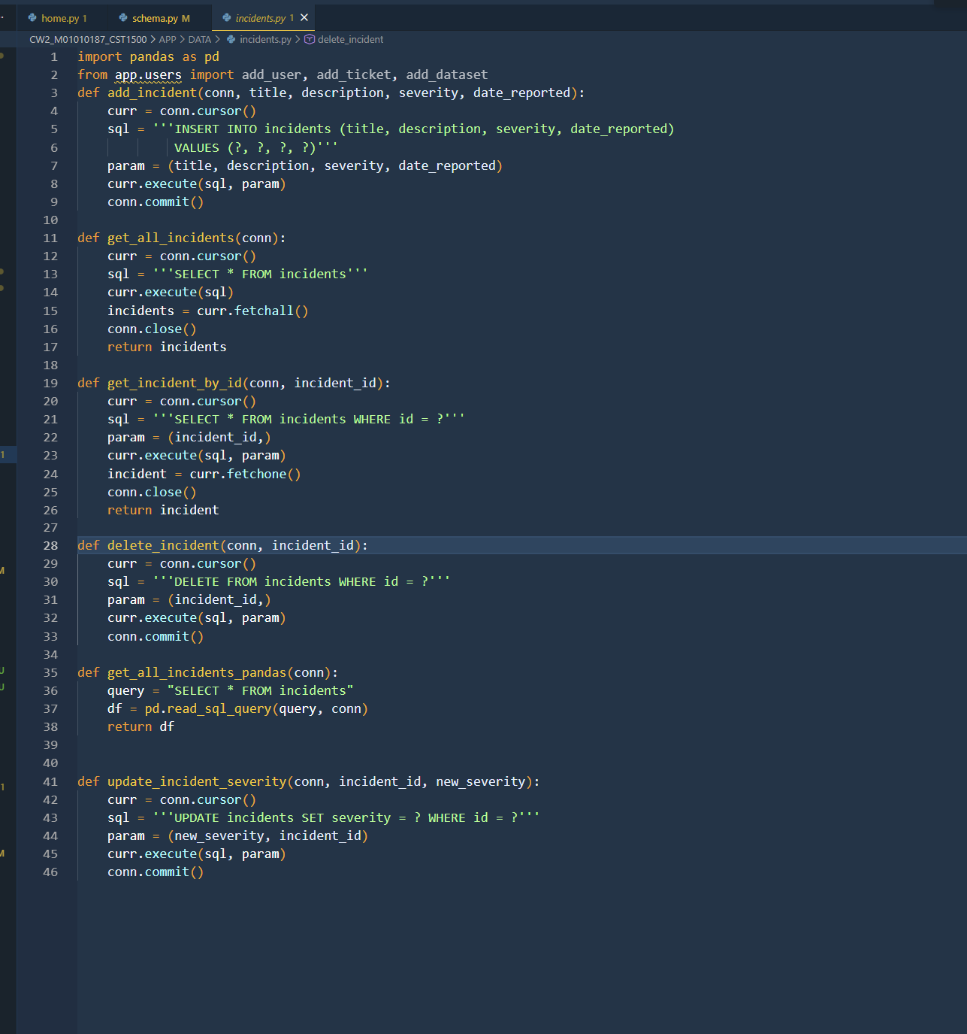
Datasets.py screenshot
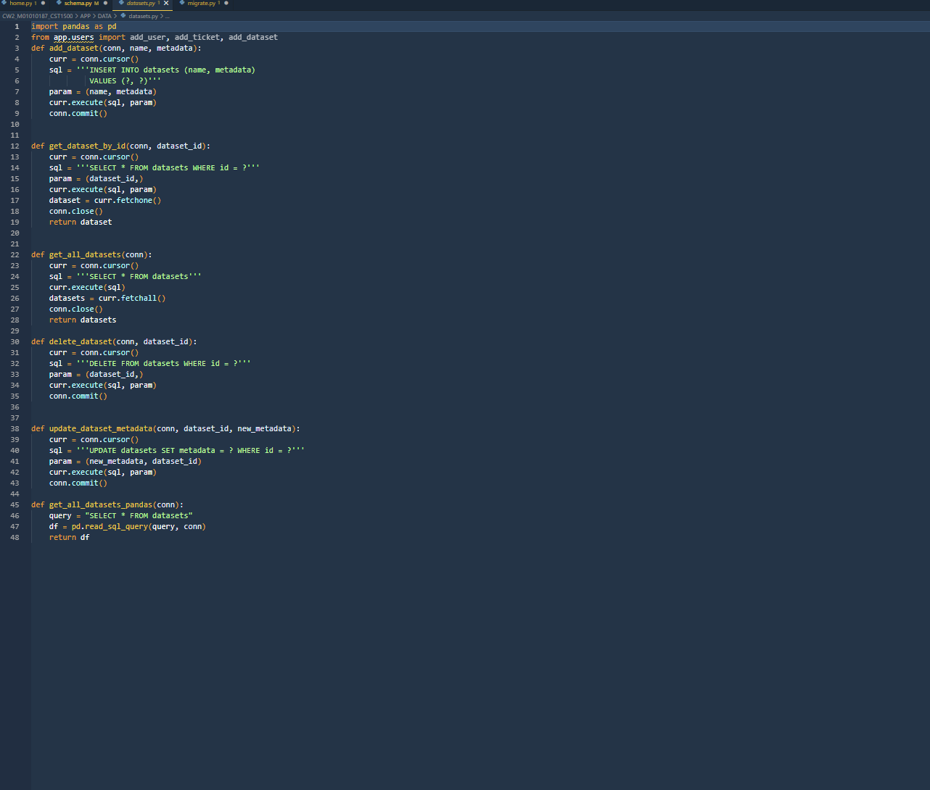
Migrate.py screenshot
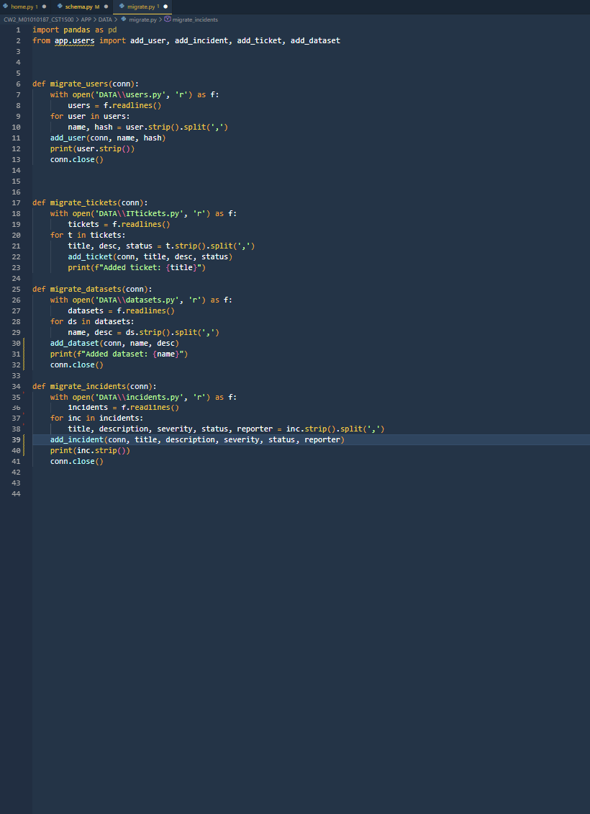
Tickets.py screenshot
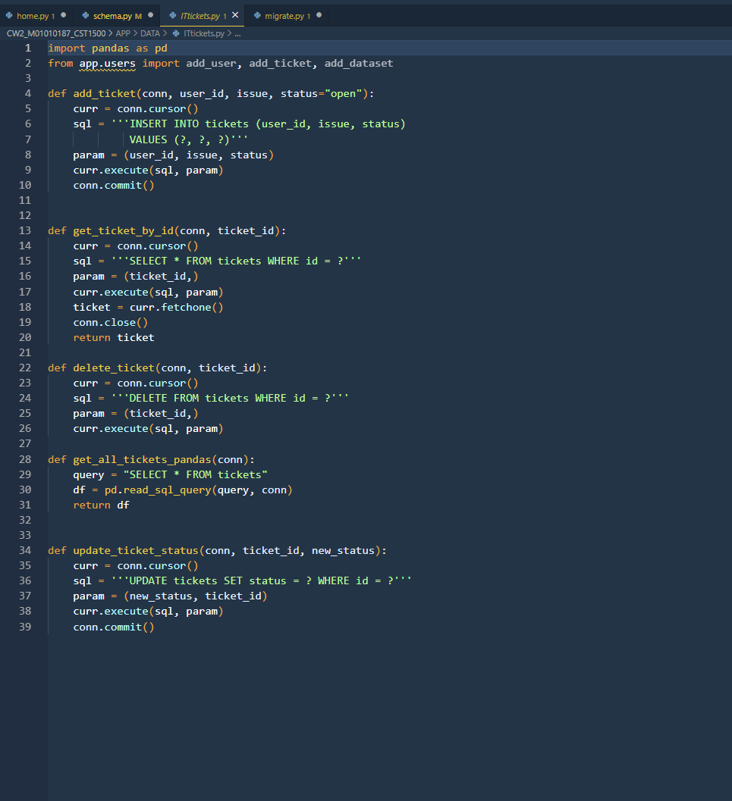
Users.txt screenshot
It operations.py screenshot
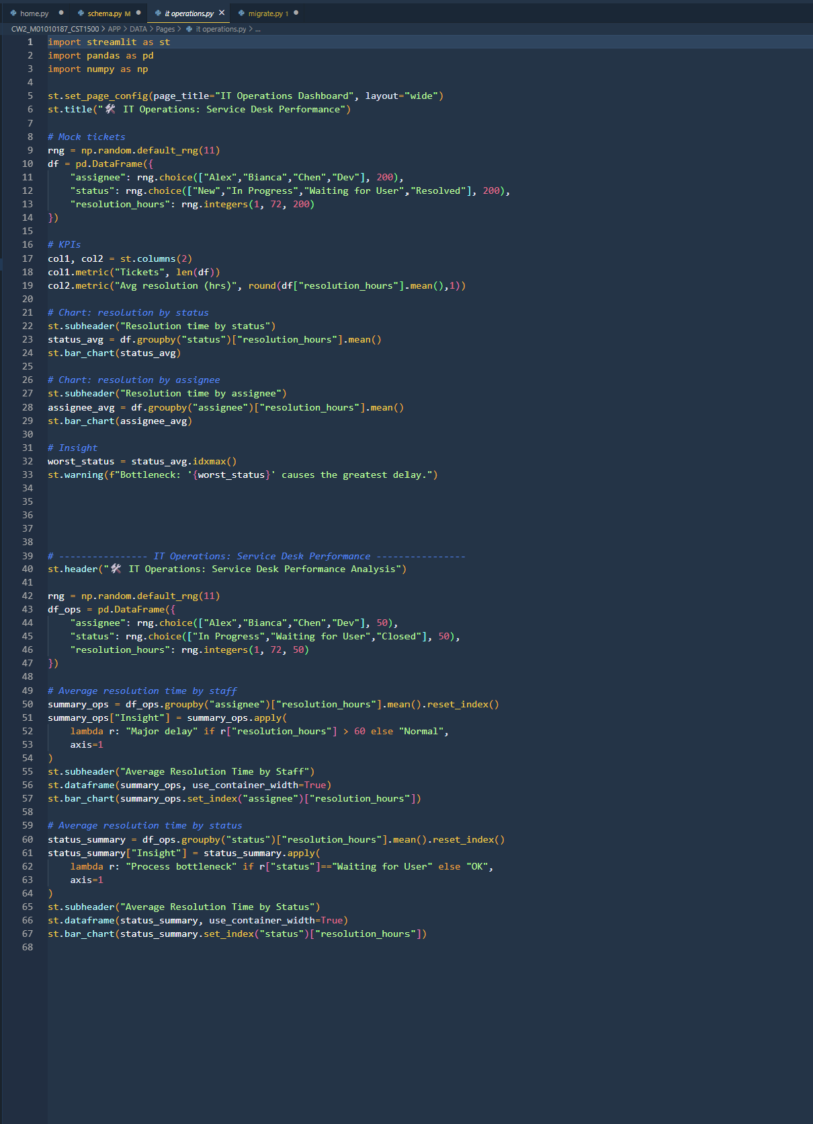
Datasets and metadata.py screenshot
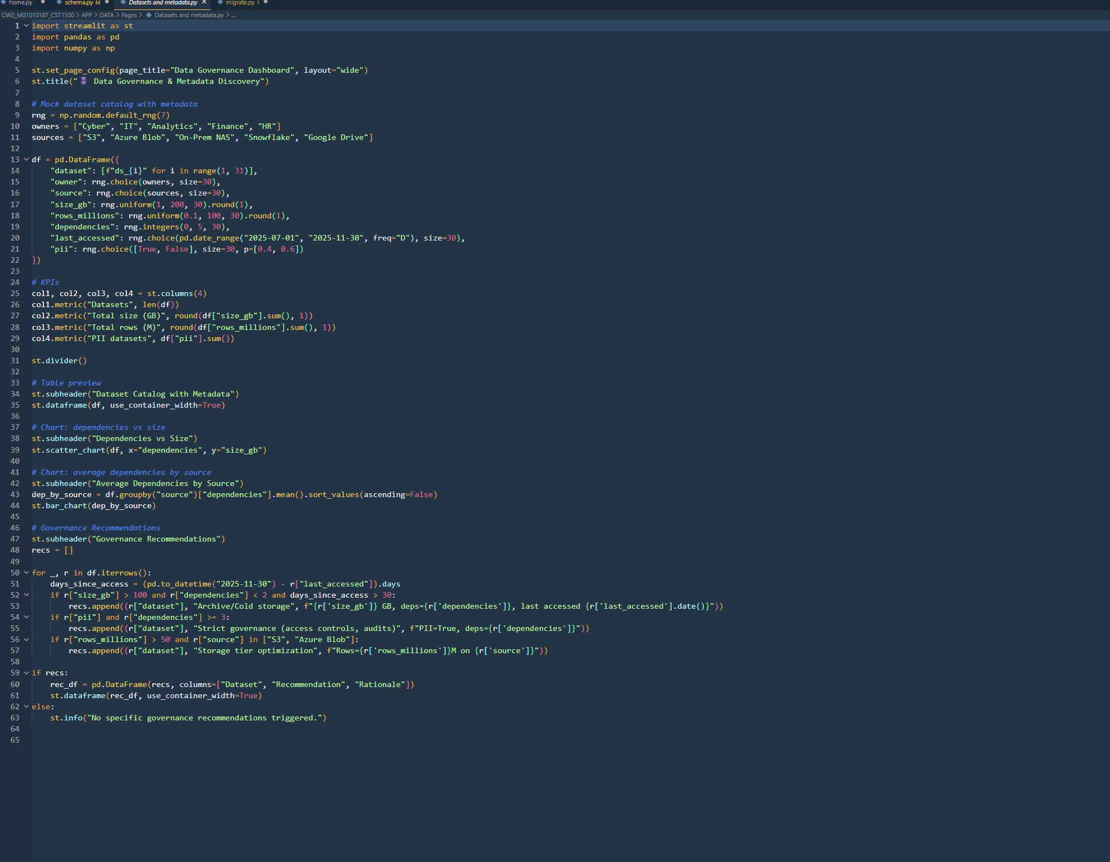
Login.py screenshot
Cybersecurity.py
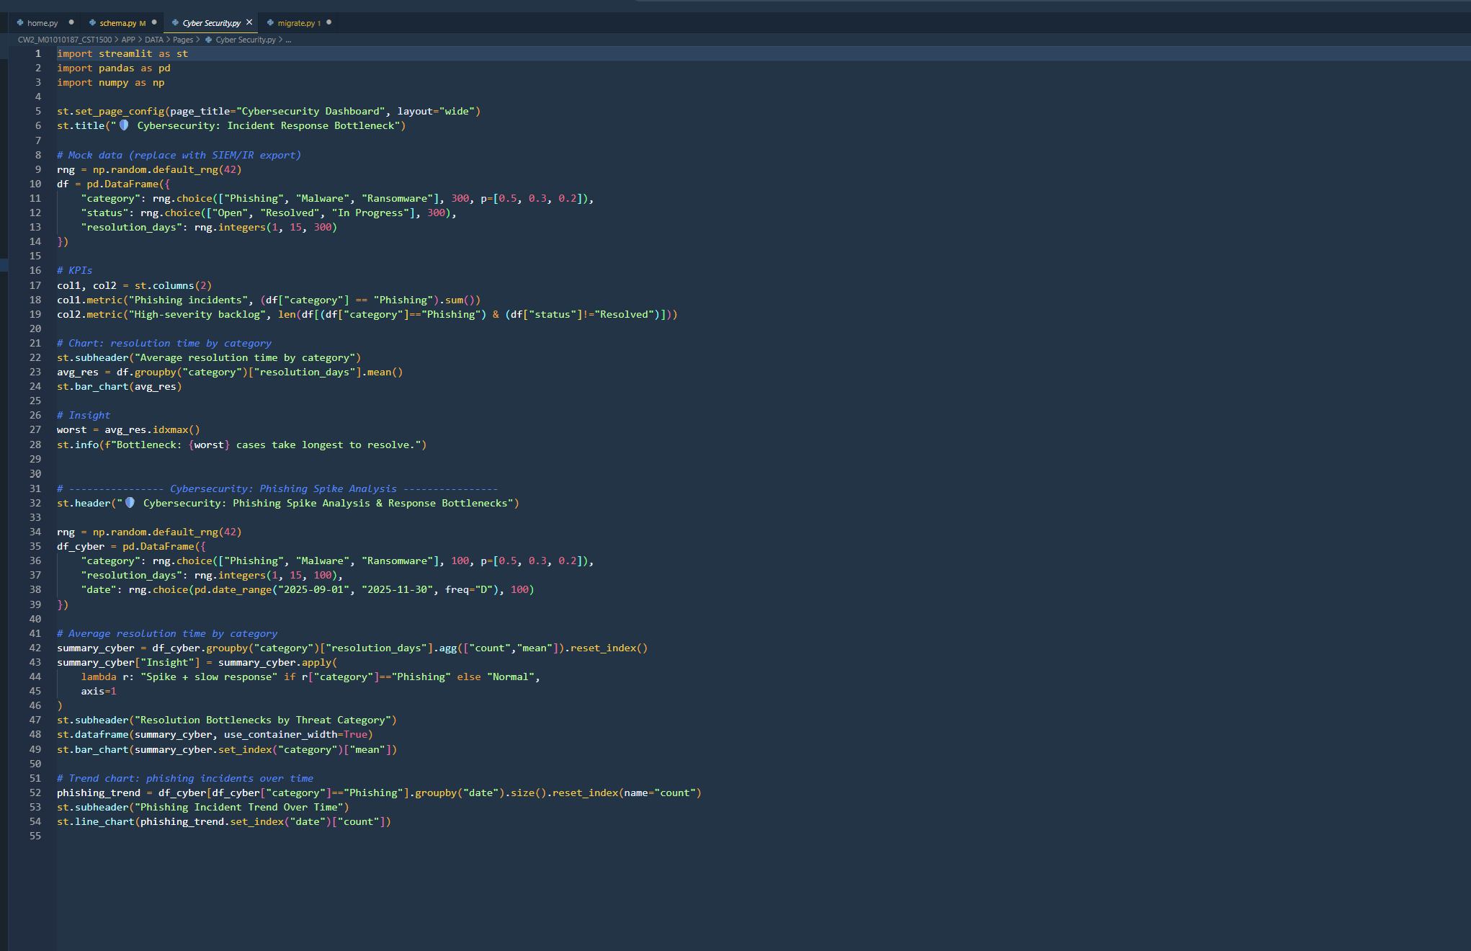
Schema.py
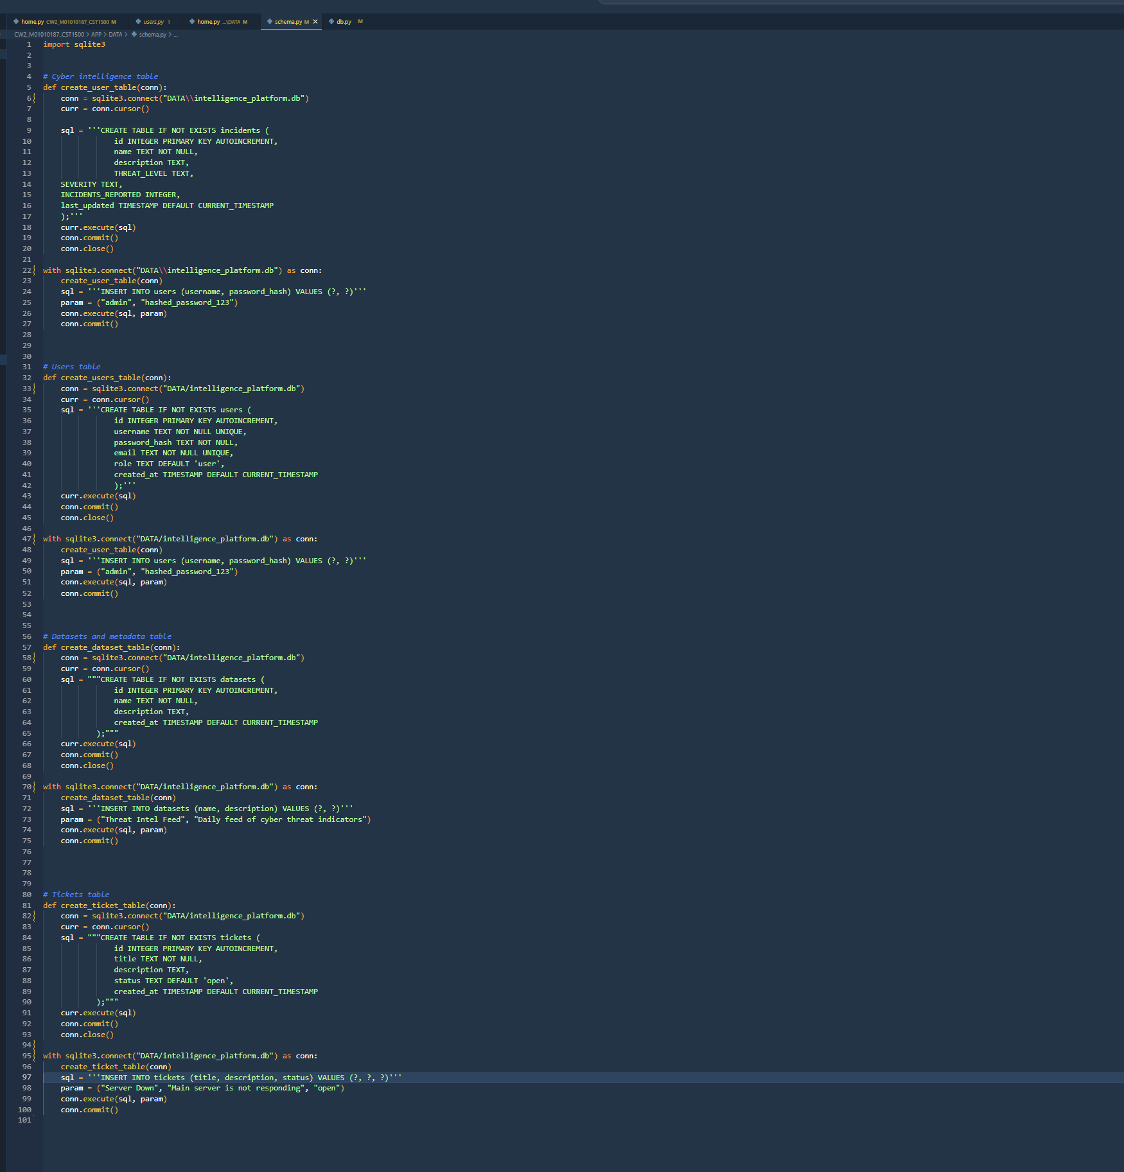

Home Page screenshot
It operations Page screenshot
Datasets and metadata Page screenshot
Login Page screenshot
Cybersecurity Page screenshot

Notes: DO NOT copy the template instructions into your report! This template shows you:
- WHAT to write (the section headings)
- HOW MUCH to write (word counts)
- NOT the actual words to submit

